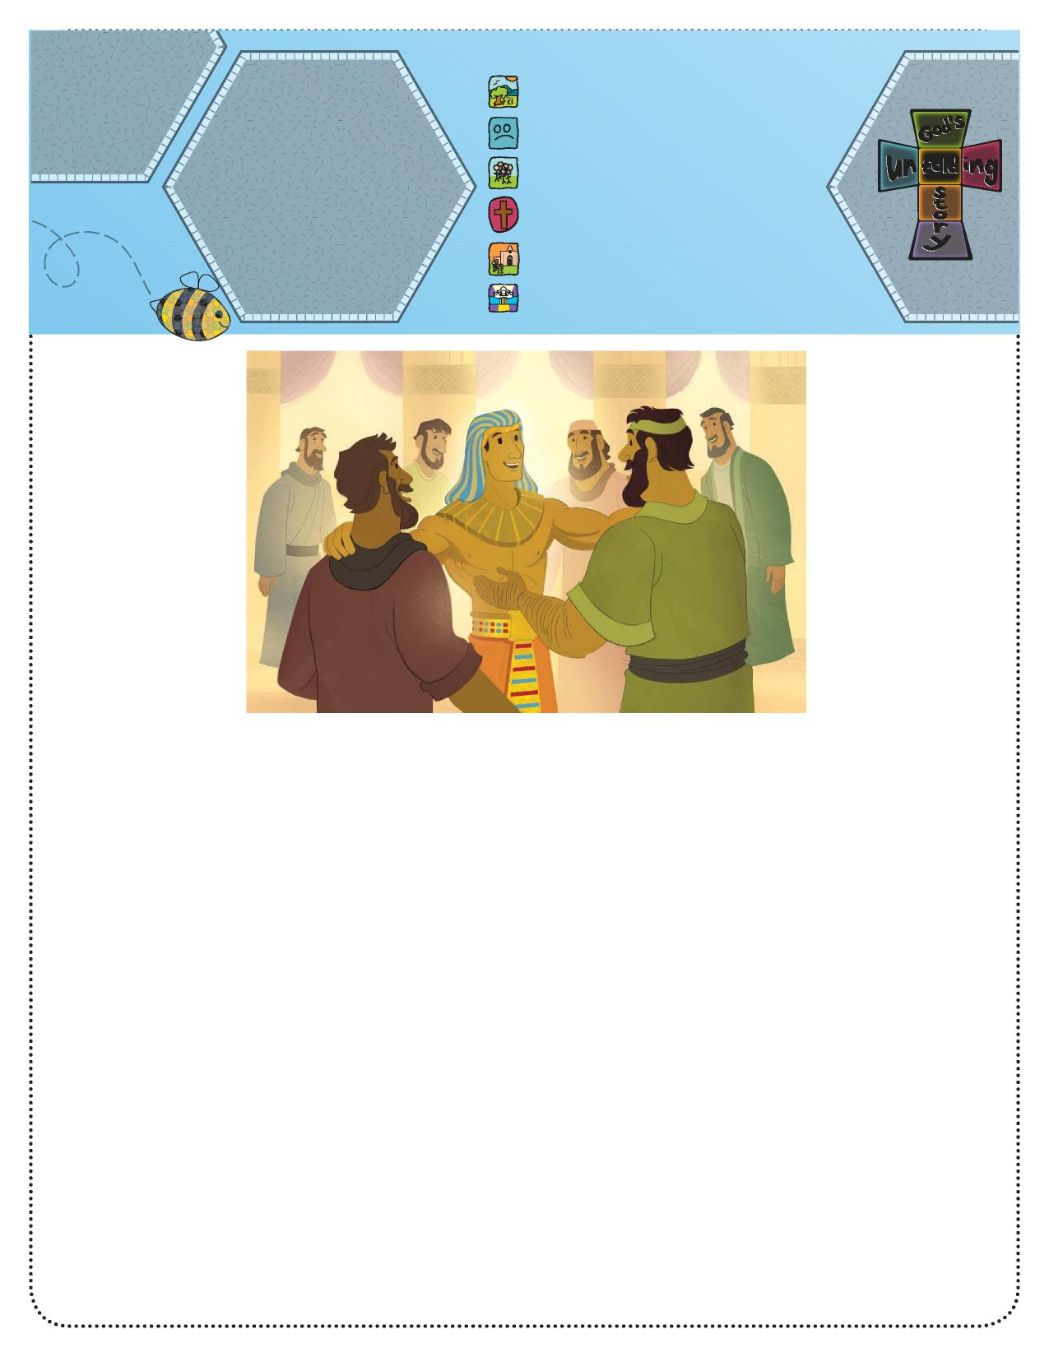

**God’s Unfolding Story**

**Parents Connect**

**Bible Story:**Joseph and His   
Family (Genesis 42–47)   
**Bible Phrase:** “Be   
kind and forgiving to one   
another” (Ephesians 4:32).   
**Bible Truth:** God can help   
me love and forgive   
those who have been   
unkind to me.

1. God created everything.
2. People disobeyed God.
3. **God chose a special people.**
4. God sent Jesus to help us.
5. Jesus began the Church.
6. Jesus is preparing heaven for us.

**Unfolding God’s Story for Parents**

We have been studying about God’s presence with Joseph throughout his life. This is the last lesson in the series, but it just might be the best because it is a story of forgiveness and family love.

they remembered how they had treated Joseph years before. The brothers had laughed at his dreams and his special coat. In their anger, they had made a bad decision that sent Joseph far away. Still, Joseph told them not to be afraid; he would forgive them for being unkind.

Joseph hugged all of his brothers and

gave them plenty of food. Then he said, “Hurry home and

bring back our father and your families. You can live with

me in Egypt.”

Soon Joseph’s family came to live in Egypt. They must have been happy to be together. God was with Joseph and took care of him and his entire family.

Ask, “Do you

sometimes get mad at your mom or dad or your

brother or sister?”

Say, “Sometimes in families we are unkind. In today’s story

we see how Joseph loved his brothers, even after they

were mean to him.”

Tell the story.

**Bible Story**

**Joseph and His Family (Genesis 42–47)** Jacob and his sons lived in the land of Canaan, but the crops were not growing and there was little food. Jacob learned they could buy food in Egypt. Jacob told his sons, “Go to Egypt and buy food for us.” So, ten of his sons left for Egypt to buy food for their families.

When the brothers reached Egypt, they went to the ruler who was selling the food. The ruler looked very important. He was dressed up like an Egyptian king. They did not realize this man was their younger brother, Joseph! But Joseph recognized them. He did not tell them who he was but gave them food to take back to their families.

Later the brothers returned to buy more food. This time Joseph told them who he was. They were afraid, because

Ask, “Is it easy to forgive when someone has hurt your feelings?”

Say, “Just as God helped Joseph forgive, his brothers, God can help us.”

Pray: Thank You, God, for helping us to forgive others and be helping us to be thankful for our families.

**Activity Suggestion**

Make an “I Love My Family Cube.” Use an empty square tissue box or another box about that size. Help glue colored construction paper to the box, then glue family photos, one on each side of the box. Use the open top to store items from your child’s room such as crayons, markers, plastic flowers, etc.