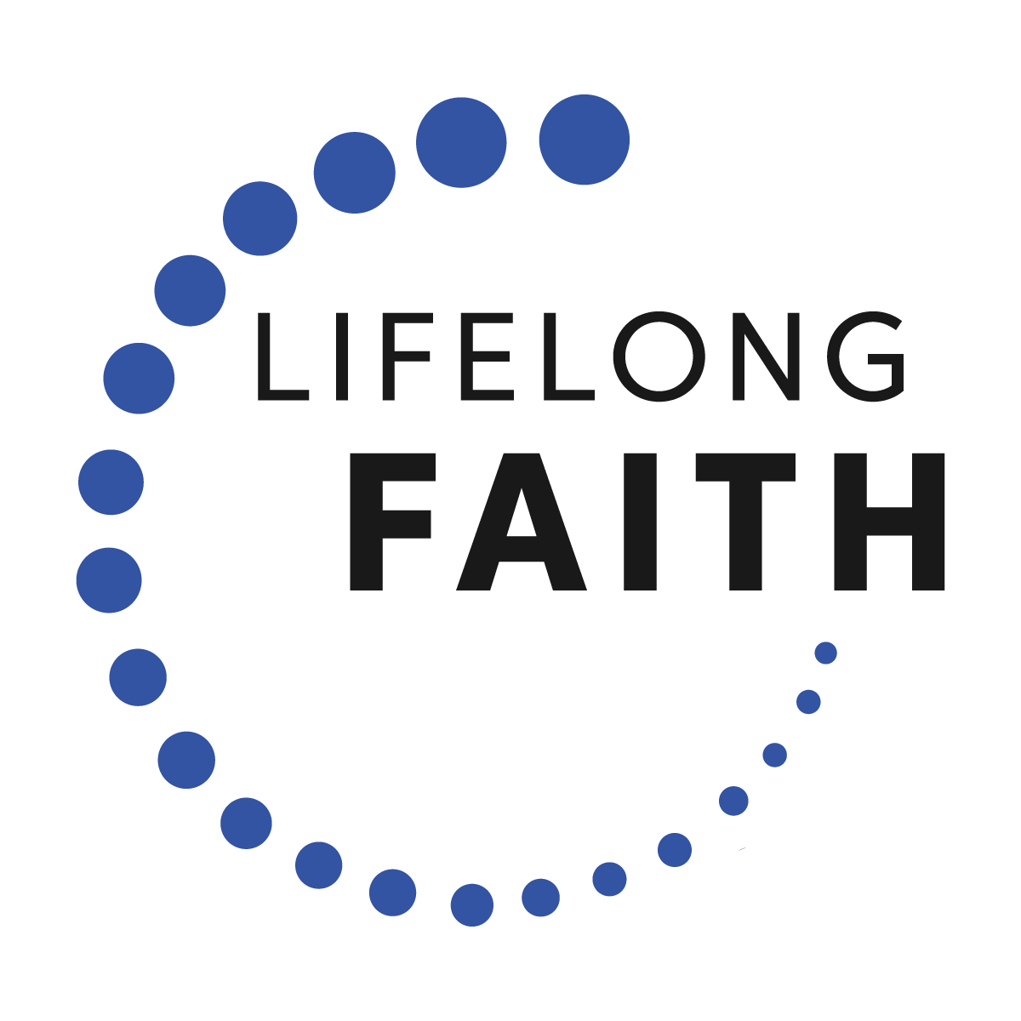 | The Practice of  Participating in Community  Experiences of  Participating in Community

There are five activities in the Practice of Participating in Community that include a teaching plan and the activity. All of the activities are also included on a separate MS Word document so that you can create handouts for sessions, a digital or print booklet, online playlists and activities, social media posts, and more.

Activity 1. How Are You Participating in Community?
Activity 2. The Christian Practice of Participating in Community
Activity 3. Identifying Gifts and Talents
Activity 4. Connecting Gifts with Ways to Participate in Community: Church, Civic Community, and World
Activity 5. Prayers for Participating in Community

Children Activities

There are four children’s activities that can be used in a children’s program and family activities. They can be found at the end of this guide and online as a separate file.

- Participating in Our Community
- Jesus Participates in Community
- We Participate in Community
- Try It!—Participate!

How Are You Participating in Community?

There is a disturbing scene in the movie The Shawshank Redemption when Brooks, an older man who has been in prison for decades, is released on parole. He rents a small, empty apartment in the city. In a horrifying moment of desperate loneliness, he hangs himself surrounded by the sounds of a vibrant urban community, to which he feels absolutely no connection. When he was in prison, he knew his place in the community. He felt a sense of connection with his fellow inmates. He had familiarity. He belonged. He was released into a world that was unlike the one he had just left, and also unlike the one that he was snatched from decades ago when he was first incarcerated. Everything had changed. He had no one to greet him at the prison gate. He had no family with whom he could reunite. He had no skills to help him participate in community. He couldn’t begin to imagine how he could belong, and so he simply checked out of life. In this story we see our fundamental need to participate meaningfully in community. In fact, we cannot survive without some sense of connection to others. We need to belong and participate!

There are forces that make it hard for us to participate in community. We find ourselves busy at home and work. There doesn’t seem to be enough time to get involved in church or our community, let alone the world.

It comes as no surprise that parents are busier today than in the past. In spite of that, research shows that the amount of time parents spend caring for their children has actually increased over the past 40 years.

This time has been taken from housework, sleeping and eating, married couples time together, time with friends, and civic and social activities. It seems that we are less involved in our churches and communities at a time when we hunger for belonging and participation.

Did You Know?

Participating in community—church, civic, and world—has positive benefits for us and for our household. Many studies have shown that people who go to church regularly are healthier physically, emotionally and mentally than people who do not go to church. For example, studies have shown that active church members live seven years longer, on average, than people who do not go to church (and it is fourteen years longer for African Americans); have a lower risk level for depression and suicide; and report that they live a “very happy” life. The Search Institute has found that young people who participate an hour a week or more in church activities are less likely to engage in high-risk behaviors and more likely to demonstrate positive characteristics (getting good grades, resisting danger, maintaining physical health, and leadership).

Research also shows that youth who have a variety of meaningful relationships with peers, older people and younger children are more likely to find joy and satisfaction in life than those who restrict themselves to just a few friends their own age. These intergenerational relationships seem to help youth do better in school. They also keep young people connected to church. More than interesting activities, the sense of belonging to a church community attracted and held teens in the church.

The participation of the whole family in church life is essential to the faith life of children and teens. In a national study on youth and religion, researchers concluded that the best way to get most youth involved in and serious about their faith communities is to get their parents more involved in and serious about their faith communities. Parents can influence children and teens in what they believe and how they practice their faith by maintaining a church attendance rule even into the teen years. Young people with the most consistent exposure to a church environment—especially in the areas of church attendance, praying, Bible reading, and knowledge of church tradition—were the most likely to remain in the tradition.

It seems that participation does matter!

How Are You Participating?

In what ways are you and your household involved in your church community throughout the year? How could you be more involved?

In what ways are you and your household involved in activities and projects in your civic community? How do you and your household make a positive contribution to your civic community?

In what ways are you and your household involved in the world community—making a positive contribution to people around the world?

How do you balance “family time” with “community time”?

The Christian Practice of Participating in Community

Participating in the Church Community

When she [my pastor] was about seven, her best friend got lost one day. The little girl ran up and down the streets of the big town where they lived, but she couldn’t find a single landmark. She was very frightened. Finally a policeman stopped to help her. He put her in the passenger seat of his car, and they drove around until she finally saw her church. She pointed it out to the policeman, and then she told him firmly, “You could let me out now. This is my church, and I can always find my way home from here.”

And that is why I have stayed so close to [my church]—because no matter how bad I am feeling, how lost or lonely or frightened, when I see the faces of the people at my church, and hear their tawny voices, I can always find my way home. (Anne Lamott in Traveling Mercies: Some Thoughts on Faith)

Christians join together in church communities to support each other in carrying on the mission of Jesus. Jesus, who is the center of the Christian community, told us, “Where two or three come together in my name, I am there with them” (Matthew 18:20). While there is no doubt that our first and most influential encounter with God happens in our homes, it is also necessary to nurture our faith by joining with other Christians in a church community.

The Christians who lived in the years following Jesus’ life, death, and resurrection expressed their faith in a loving God by building communities of love and mission. The New Testament records their efforts in all kinds of ways, but one of the clearest examples is found in the Acts of the Apostles. (There is a similar description of the early Christian community in Acts 4:32–35.)

Many miracles and wonders were being done through the apostles, and everyone was filled with awe. All believers continued together in close fellowship and shared their belongings with one another. They would sell their property and possessions, and distribute the money among all, according to what each one needed. Day after day they met as a group in the Temple, and they had their meals together in their homes, eating with glad and humble hearts, praising God, and enjoying the good will of all the people. And every day the Lord added to their group those who were being saved. (Acts 2:43–47)

Churches are communities of faith, of action, and of hope. Here the gospel is proclaimed and celebrated; here believers are formed and sent to transform the world. Within the church community, God’s people meet Jesus in word and sacrament, and come in touch with the source of Christian life.

The same Spirit and mission that gave birth to the early Christian communities gives life to Christian churches today. The Christian community shows the presence of Christ to the world. We are joined together as members in the one body of Christ with a diversity of gifts that we use in service to God’s kingdom.

We have many parts in the one body, and all these parts have different functions. In the same way, though we are many, we are one body in union with Christ, and we are all joined to each other as different parts of one body. So we are to use our different gifts in accordance with the grace God has given us. If our gift is to speak God’s message, we should do it according to the faith we have; if it is to serve, we should serve; if it is to teach, we should teach; if it is to encourage others, we should do so. Whoever shares with others should do it generously; whoever has authority should work hard; whoever shows kindness to others should do it cheerfully. (Romans 12:4–8)

The Christian practice of participating in the church community engages us with other Christians in a common effort to live the mission of Jesus Christ today. We join a community that supports each other in good times and bad, celebrates their faith in worship, is continually learning about the Christian faith and what it means to follow Jesus Christ today, and utilizes their gifts and talents in service to the church and world.

Participating in the World

Christians have a mission and gifts that are meant to be shared beyond the walls of their homes and churches, so it’s important to get out and get involved in our local civic communities.

The Lord Almighty, the God of Israel, says to all those people whom he allowed Nebuchadnezzar to take away as prisoners from Jerusalem to Babylonia: “Build houses and settle down. Plant gardens and eat what you grow in them. Marry and have children. Then let your children get married, so that they also may have children. You must increase in numbers and not decrease. Work for the good of the cities where I have made you go as prisoners. Pray to me on their behalf, because if they are prosperous, you will be prosperous too.” (Jeremiah 29:4–7)

Christians by nature are participators. Christian love never stops at the doors of the church; it overflows into the civic community that surrounds the congregation. We don’t fulfill our destiny by burying ourselves in our churches to protect ourselves from the evils in the world. We need to get involved to make our communities better places to live. It is an expression of our faith in God to get involved economically, socially, and politically in our community.

Christian participation in the civic community inspires others when it shows a loving concern for the poor and marginalized members of the community.

When you harvest your fields, do not cut the grain at the edges of the fields, and do not go back to cut the heads of grain that were left. Do not go back through your vineyard to gather the grapes that were missed or to pick up the grapes that have fallen; leave them for poor people and foreigners. I am the Lord your God. (Leviticus 19:9–10)

Whenever you possibly can, do good to those who need it. Never tell your neighbors to wait until tomorrow if you can help them now. (Proverbs 3:27–28)

Christians don’t use all of their economic and material resources for themselves; they set aside a portion for those who don’t have enough. People can see the presence of God when Christians reach out in love to the poor. Christians express their faith in loving action for the benefit of the whole world. When a child dies from hunger in a remote village in a poor nation far away, Christians are concerned because God embraces that dying child. When workers are oppressed with low wages and unsafe working conditions, Christians are concerned because God’s law of justice is being violated. When species of animals and plants are disappearing from the face of the earth due to the consumption of forest land, Christians are concerned because unique expressions of God’s creation are gone.

The first Christian communities were inspired to care for people beyond their borders with these words:

Remember that the person who plants few seeds will have a small crop; the one who plants many seeds will have a large crop. You should each give, then, as you have decided, not with regret or out of a sense of duty; for God loves the one who gives gladly. And God is able to give you more than you need, so that you will always have all you need for yourselves and more than enough for every good cause. (2 Corinthians 9:6-8)

Participating in a church community means participating in service to the world. Churches all across the country are serving beyond their borders.

Identifying Gifts and Talents

I am of the opinion that my life belongs to the whole community, and as long as I live, it is my privilege to do for it whatever I can. (George Bernard Shaw)

There are tremendous benefits that come with participating deeply and meaningfully in a community—whether it’s a Christian community, your local community, or the world. Whether you are a single young adult, a newly married couple, a family with children or teens, a single adult, an “empty nest” household, or an older adult, there are lots of ways you can become more deeply involved in your church, neighborhood, and world. Let’s explore the gifts that you bring to community, and some of the ways you can utilize those gifts more fully.

Identifying Gifts & Talents

Each one, as a good manager of God’s different gifts, must use for the good of others the special gift he has received from God. (1 Peter 4:10)

“Each of us is like a gift package from God. Our combination of gifts is unique. Not one of us has ever been replicated on this earth! Our giftedness includes our talents and abilities, styles, interests, experiences, preferences, and passions for serving in the world. Our gifts are part of an abundant web of giftedness in our faith community. These gifts were given to us so that we might minister together as partners in God’s work in the world. And our gifts are meant for us too! When we live out our gifts, we discover the joys of an abundant life.” (Jean Morris Trumbauer in Created and Called)

Begin the process of strengthening your involvement in church and community by identifying your God-given gifts and talents using the “Gifts Inventory.”

Equipped with a list of your gifts and talents, and those of your household, you can now start to consider the type of activities you and members of your household might want to be involved in. Think about which interests best match with your gifts and talents.

Ways to Enhance Your Participation

Keep abreast of local, national and international events.
Subscribe to reputable news sources (in print or online) that will give you accurate information about events in your community, in our nation, and around the world. If you live with others, invite each person to select a news story for discussion at one of your meals each day. Include a Christian interpretation of the news in your discussion. Your pastor or another leader in your church can help you find resources that offer a Christian perspective on the daily news.

Pray the news.
Christians don’t just discuss the news; we place the needs of those who are suffering at the foot of the cross. We pray that God’s transforming power, the power that turned the death of Jesus into resurrection, will also transform the suffering in our communities and around the world. We are
a hopeful people who believe that our prayer, accompanied by our good works, will make
a positive difference in the world.

Respond to tragedy generously.
Keep your eyes and ears open for people and places in need. Discuss with the members of your household how you can respond financially and personally.

Prioritize your participation.
We have to make good choices about how we will be involved and how to balance our involvements. There is no simple formula that will solve the priority problem for you and your household, but there are some principles that might be helpful:

Keep talking and listening. Communicate regularly with those in your household about what is important to you. Listen closely and respectfully to what is important to them. In two-parent households, the parents should work hard to share priorities as much as possible and communicate them consistently to their children. Communicate regularly with the leaders of the organizations to which you and your family belong. Let them know as soon as possible when you have a concern or anticipate a schedule conflict.

Acknowledge that God is present everywhere all of the time. While some activities must take priority over others, it does not mean that lower priority activities are unimportant. When you set a church or family event as a priority over a recreational event, be careful not to give the impression that the recreational event has no value. Don’t suggest that you are choosing God over sports or a party; rather, you are choosing one way of experiencing God over another way at this particular time for a specific reason. Be clear about your reason.

Once you’ve established your priorities, stick to them. If you have children, don’t let their complaining break you down. State your priority, state why it is your priority, and suggest that a discussion about it can happen later when the complaining stops.

Never stop participating with your children.
Many parents make the mistake of disconnecting with their children when they become teenagers. Yet recent studies show that teens desire meaningful family time more than anything else. They also love having positive and active relationships with their parents. While teens often appear to be quite grown up, they still lack many necessary skills for responsible community participation. They simply will not acquire these skills by hanging out with friends who also lack the skills necessary for mature adulthood. Stay involved with your teens.

Participate intergenerationally.
We often fall into the temptation of participating in community only with people who are our own age. There is certainly nothing wrong with developing friendships with our peers, but we don’t experience the fullness of community life unless we connect with people of all ages. We have much to give and receive from people who are older and younger than we are. Our schooling, which is heavily age- segregated, inhibits us from developing strong intergenerational skills. Parents need to intentionally find ways to regularly connect their children with trusted adults of all ages in their community. Parents and children can connect with older adults in their community through church programs, nursing home visits, neighborhood block parties, neighborhood services to older adults, so on.

Be politically active.
Write to your elected representatives about issues that matter to you. Learn the positions of political candidates and vote. Explain to your family that it is important for Christians to share their values with the community through political participation. Keep your perspective in balance. Christians may use politics as a tool to help a community achieve its goals, but politics will not be the ultimate solution to community problems. Government is only one part of society. The daily choices of citizens in their homes and in their interactions with each other are far more powerful in determining the health of a community. Many denominations prepare guides to political elections that articulate Christian teaching and its application to social issues. Check with your church or denomination for information.

Discuss the issues and pray for the candidates.
Discuss the candidates’ positions on issues during mealtime, and pray for all candidates. Answer questions your children or grandchildren have about political issues. If you don’t know the answers, research the issue together online or at the library.

Gifts Inventory

Each one, as a good manager of God’s different gifts, must use for the good of others
the special gift he has received from God. (1 Peter 4:10)

Each of us is like a gift package from God. Our combination of gifts is unique. Not one of us has ever been replicated on this earth! Our giftedness includes our talents and abilities, styles, interests, experiences, preferences, and passions for serving in the world. Our gifts are part of an abundant web of giftedness in our faith community. These gifts were given to us so that we might minister together as partners in God's work in the world. And our gifts are meant for us to enjoy too! When we live out our gifts, we discover the joys of an abundant life.

This inventory will help you identify your own gifts, and help our church community recognize and celebrate the abundance of our gifts.

About You

Name:
Address:
City/State/Zip
Home Phone
Email
Age
- 20-29
- 30-39
- 40-49
- 50-59
- 60-60
- 70-79
- 80 and over

Special Information

- I am interested in becoming more involved in the ministries of St. Bridget of Sweden Parish. Notify me of opportunities that fit my gifts.
- I am interested in changing some of my current commitments.
- I prefer a one-time commitment (1 hour to 1 day).
- I prefer a short-term commitment (up to 6 months)
- I prefer a specific, longer term of service (1 year or more)
- I am satisfied with my current involvements in the ministries of St. Bridget of Sweden Parish.
- I am unable to take on additional commitments at this time.
- I would like to talk with a member of the team about my using my gifts.
My gifts are…  Check up to a dozen things you do well. Feel free to add other gifts not specifically listed.  - accounting/finances/budget  - acting/drama  - artwork/crafts  - caring and compassion  - carpentry/building  - child care  - clerical work  - communication  - computer skills  - cooking and serving food  - coordinating and organizing projects  - dancing  - decorating  - facilitating and working with groups  - faith-sharing  - fundraising  - gardening  - graphic design  - hospitality  - housekeeping  - legal services  - listening  - maintaining buildings/grounds  - mechanical work  - mediating and problem-solving  - medical/nursing care  - mentoring/tutoring  - music: instrumental or voice  - photography  - planning/visioning  - praying  - promotion/advertising  - public speaking  - researching  - sewing  - social justice work  - sound recording/audio production  - teaching/training  - video and video production  - visiting others  - web design  - writing  - ___________________________ | I have experience or interest in these areas of involvement. . .  Mark the 5 greatest areas of experience (E) with +  Mark the three greatest areas of interest (I) with  E I Potential Involvement  _____ _____ arts  _____ _____ children’s ministry  _____ _____ care for and dignity of the elderly  _____ _____ consolation/grief ministry  _____ _____ communications  _____ _____ community outreach/service  _____ _____ data administration  _____ _____ disabilities / special needs  _____ _____ education: children  _____ _____ education: youth  _____ _____ education: adults  _____ _____ environment / care for the earth  _____ _____ family ministry  _____ _____ finance  _____ _____ global mission  _____ _____ grief and loss  _____ _____ health ministry  _____ _____ media (photography, videos)  _____ _____ music  _____ _____ new member welcome  _____ _____ pastoral care  _____ _____ prayer ministry  _____ _____ addiction and recovery  _____ _____ sacramental preparation  _____ _____ service to the poor and vulnerable  _____ _____ singles ministry  _____ _____ small faith communities  _____ _____ social justice  _____ _____ social/community life  _____ _____ spiritual growth  _____ _____ stewardship  _____ _____ web ministry  _____ _____ worship/liturgy  _____ _____ young adult ministry  _____ _____ youth ministry

Prayers for Participating in Community

Generous God,
We thank you for all the gifts you have given us.
We know that all we have received is from your hand.
Gracious and loving God, you call us to participate in the life of our communities,
our church community
our civic community
our world community
Help us to always use your gifts wisely and teach us to share them generously.
Send the Holy Spirit to work through us, bringing your message of love to those we serve.
May we bear witness to the love of Jesus Christ in our lives every day.
We pray with grateful hearts, in Jesus’ name.
Amen.

* * * *

Praying for Our Community and World

God who is Father, Son and Holy Spirit:
you call us to live in unity
with all the members of our community.
We pray for all of the people and organizations
that help to create a sense of belonging among us all. We pray for our families,
that they will be schools of love.
We pray for our schools,
that they will inspire great thoughts. We pray for our businesses,
that they will create beneficial goods and services.
We pray for our clubs and organizations,
that they will be open to all and fair with their members.
We pray for our politicians,
that they will lead with humility and wisdom.
We pray for those who are different from us,
that they may become our friends.
We pray for our churches,
that they will uncover the hidden face of God in everything we do and in everyone we meet in our community.
We pray for the communities, the nations, the world, and the universe of which we are a part,
that we may be one.
We pray for ourselves,
that we will participate in our communities
so that God can bring our prayers to fulfillment.
Amen.

